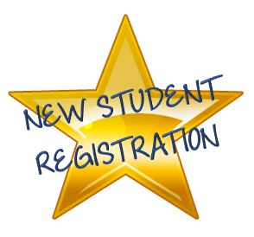
Registration Requirements

All registrants must provide the following documents:
- Your child’s birth certificate
- Your child’s immunization record
- Residency documents as listed below

Please provide one (1) of the following:
*Lease or rental agreement requirements:
~If renting from real estate management company or commercial lessor, the signed lease containing the name of the parent, date, lease end date, address, and signatures.
~If renting from a private owner, the signed lease containing items as listed above AND property owner’s deed, tax bill or proof of ownership as listed.
- Deed to establish ownership of dwelling
- Signed settlement sheet
- Title, establishing ownership
- Mortgage statement or coupon book
- Real Estate Tax Bill (current year)
- Lease or rental agreement *

AND…three (3) pieces of mail, postmarked or billing date shown must be within the past 60 days of registration. Documents should be from 3 different sources. Examples listed below:
Gas and Electric Bill | First Class Mail from a business or agency
Credit Card Bill | Health center mailing or appointment verification
Cable Bill | Motor Vehicle Administration
Court Document | Cell Phone Bill
Pay Stub | Mailing from a BCPS school or office
Voter’s Registration Card | Change of address verification from Post Office
Federal or State Income Tax Return for the preceding year
W-2 Form | Water Bill

AND…Parents / guardians must provide a photo ID at registration.
Residency Requirements
In accordance with BCPS Superintendent’s Rule 5150, Enrollment and Attendance, prior to enrollment, a school administrator or designee will require the documents listed below. These documents should contain the name of the parent / legal guardian and the current address.

If you are sharing a residence with another family and / or your name is not on the property or lease, you must contact the shared domicile office at 443.809.6363 to establish residency in Baltimore County.

Registrants who have attended another school previously to enrolling at Honeygo should also provide:
- Name, address, and phone number of previous school
- A copy of the last report card
- Notice of any special services the child was receiving.
Students transferring from a public school in Maryland should obtain a Maryland Student Transfer packet from the previous school. Please bring this packet with you at the time of registration.
Kindergarten (5), Prekindergarten (4) and Preschool (3) students must be the appropriate age by September 1st. Additional paperwork is required for these students.

